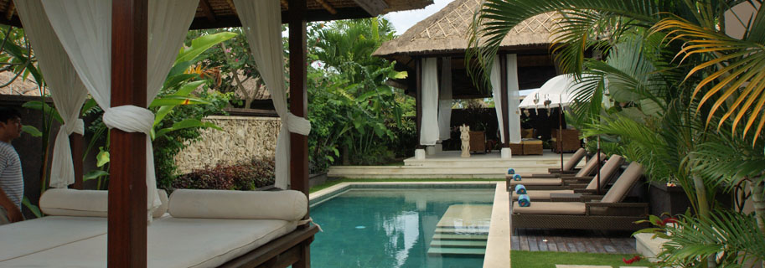
Libby’s Girls Weekend in Bali

Programme
Day One
Arrival day…Yippee!
Our car and driver will pick you up from the airport based on the details you have provided. The first get together will be dinner 6pm at Beach House, Echo Beach. Cars will depart from the villa at 6pm or if you are arriving after this time your airport transfer can bring you straight to the Beach House from the airport and take your bags back to the villa. Beach BBQ Seafood, casual and cheap!
If you are arriving earlier a set lunch can be pre ordered in your villa – just let me know.

Day Two
Shopping and Eating Day!
Breaky in villa. Depart villa around 9.30am for the Seminyak Road Shopping Run accompanied with car and drivers to carry your shopping bags along the way. We will walk for as long as possible along this shopping strip until you need food or a cocktail – whichever comes first! Lunch will be 1pm-ish at Cocoon Beach Club which is close by to the shopping run, overlooking Legian Beach. A young exciting chef Luis Varela Mata from the previously famous Spanish restaurant El Bulli has joined the team here – so foodies should love this place. Casual dress.
Afternoon is flexible, hard core shoppers can keep going or you can retreat back to the villa for a spa treatment, or a relax by the pool.
Dinner is at Hotel Tugu at 8pm. (Approx 5 mins from the villa) We have booked the special Bali Puputan private dining room with Balinese Banquet. This is a very special experience.
Day Three
Exercise, do nothing, then eat again day!
A flexible day. Breaky in villa. Around 9am we can walk off some of yesterday’s indulgence by taking the ‘Libby’ trek around the village and rice fields, ending up at a cute little café called Betelnut for a juice, coffee or snack. Then the rest of the day is free to either take a cooking class, spa, lie by the pool or fit in some more shopping!
An 8pm dinner is booked at the famous Sarong Restaurant in Seminyak. This is a beautiful place with fantastic food served up by Chef Will Merrick who is currently taking Asia by storm. Sarong also has fantastic cocktails - a little swanky here so save your best frock for this one.

Day Four
Departure Day
Breaky in Villa. Depending on when your flight is departing, a good day to get some pool time or a final massage. A casual lunch at the Beach House around midday will be on the agenda too for those still in town.

Some other bits:
Villa breakfast is included in your room rate. We can organise drinks/snacks and other meals in villa too just let us know. You can order house wine, beer or soft drinks and have them placed in the fridge for your arrival.
We can also arrange margarita hour in your villa. If you bring in your own spirits our staff will mix for you. You will need to coordinate with your villa buddies to bring a bottle of Contreau and Tequila to do this. You can bring in one bottle of alcohol per person duty free.
Any in-villa extra costs will be billed in local currency before departure based on your villa orders.
I have sent through the Spa and Cooking School info. You can organise Spa treatments after arrival, cooking school needs to be pre-booked. These too are invoiced in local currency payable by cash.
Cash is often easiest in Bali. USD, AUD and SG bills are easily exchanged at reputable money changers. Refer to the Handy Hints guide that has been sent through for lots of villa and local info. If you have any other questions just let me know. Really looking forward to a fun weekend!
Cheers
Libby Hunter

